Manotick Curling Center - Emergency Action Plan

 | Emergency Service Phone Numbers
Ambulance | 911
Fire | 911
Police | 911
Facility Charge Person | Lindsay Allen  613 692 0520
Club Manager | Bob Vontangerloo  613 692 2086

 | Facility Information
Name | Manotick Curling Center
Location of Facility Phones | - Kitchen  - Near South East Bulletin board
Facility Phones | 613 692 1489
Facility Address | 5519 South River Drive, Manotick, Ontario,K4M 1J3
Description of Building from Road | Southwest Corner of Van Vliet Road and South River Drive  Long brown building with steel metal roof and gravel parking lot.
Directions to Facility | Directions from West:  - Starting on Manotick Main Street,  - Turn east onto Bridge Street,  - Right (south) onto Van Vliet,  - Continue on Van Vliet to stop sign at South River Drive,  - Curling Building is at southwest of this corner  Directions from East:  - Starting on River Road,  - Turn west onto Bridge Street,  - Left (south) onto Van Vliet,  - Continue on Van Vliet to stop sign at South River Drive,  - Curling Building is at southwest of this corner
Description of Emergency Entrance | Main Door:  - Front door into a vestibule. Steps up to lobby area, and steps down to ice area.  Ice Door:  - Rear Garage door entrance to ice area (no steps). These doors can only be opened from the inside.  Note: There is no Wheelchair access to the lobby
Directions to Emergency Entrance from Driveway | Main Door:  - The main door is near the entrance to the driveway and contains the sign and a glass window.  Ice Door:  - From driveway entrance off the entrance is a huge double door at the far end of the parking lot.  - This door can only be opened from the inside.

 | Medical Assistance Information
Location of Facility First Aid Kit | Kitchen  - On a hook just inside the kitchen door.
Location of Defibrillator | Kitchen  - On hook to the right of bar doorway inside the kitchen.
Location of Athlete Medical Profiles | With the team Coach
Location of Nearest Hospital | Queensway Carleton Hospital
Directions to Hospital from Facility | - Left on Bridge Street,  - Right on Main Street,  - Left onto Bankfield,  - Follow Bankfield to highway 416,  - Take highway 416 North.  - Exit at highway 416 at Hunt Club,  - Left onto Cedarview Road to the end,  - Turn Right on Baseline Road,  - Next left at lights is the hospital parking lot.
Map to the Queensway Carleton Hospital  Copyright: Google | 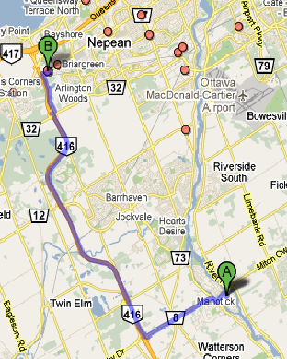

 | Other
Other | N/A
Date Completed | Oct 2013
Coach Name
Coach Signature

