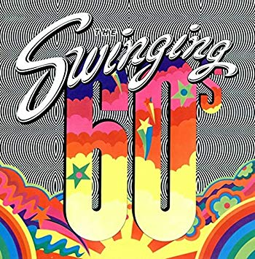
Manotick Curling Club
Swinging 60’s
Ladies Invitational
Saturday March 2, 2019

Skip: ____________________ Third: _____________
Second: __________________ Lead: ______________
Please check your draw Preference:
8:30 & 1:00 or 10:30 & 2:30

Groove out with your team for 1-8 end and 1-6 end game.
Morning coffee, lunch, and prizes for both draws.

Entry Fee: $140 per team
Make cheques payable to Manotick Curling Club. Cheques can be postdated to February 2, 2019.
To register mail this application along with entry fee to:
Mrs. Kathy Arntfield
228 Cabrelle Place
Ottawa, Ontario
K4M 0A9
Email: karntfield@hotmail.com
Phone: 613-692-1864

Contact person: ______________ Home Club: ______________
Email: ____________________ Phone: _________________

We will attempt to accommodate your draw preference.
Confirmation of entry and draw will be sent by email.

